Department | FED
subject | DSA-2
Academic Year | I-III Semester (2025-26)
Faculty Name | BALAIAH SIR
Student Name | K. Aasritha
Roll Number | 2520030178
Branch | CSE
Course Outcome

Case Study Topic: Uber Bengaluru Surge Multiplier Management Using Segment Tree with Lazy Propagation.
Work Done Summary: Developed a Segment Tree with Lazy Propagation for Uber Bengaluru's 16 geofenced zones to handle surge multiplier updates efficiently. The system performs range-add updates on selected zones and range maximum queries to find the highest surge multiplier within a given range. Lazy markers are used to defer updates, reducing computation and ensuring all operations are completed efficiently in O (log n) time. This enables fast and scalable surge management for real-time ride demand scenarios.
Implementation Details
- Constructed a Segment Tree for 16 geofenced zones to store the maximum surge multiplier in each segment.
- Used Lazy Propagation to efficiently handle range-add updates without updating every zone individually.
- Applied updates on ranges [3,9], [7,14], and [2,6] by storing pending values in lazy markers.
- Processed range maximum queries on [0,15] and [4,10] to retrieve the highest surge multiplier.
- Updated internal node maximum values whenever required and propagated lazy values only when accessed.
- Achieved efficient range updates and range maximum queries in O (log n) time.

Result: Screenshots / Output :

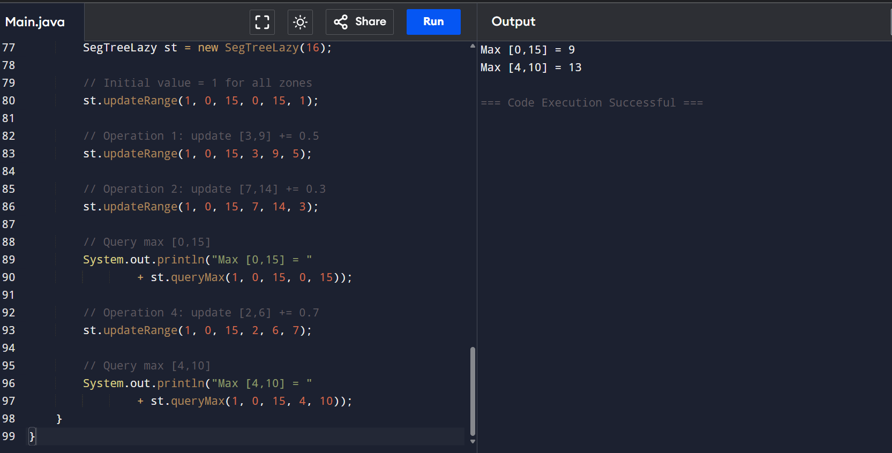
Time Complexity:
- Range Update: O (log n)
- Range Maximum Query: O (log n)
- Segment Tree Construction: O(n)

Conclusion
The Segment Tree with Lazy Propagation efficiently manages surge multiplier updates and maximum surge queries across Uber Bengaluru's geofenced zones. By delaying unnecessary updates, the system achieves O (log n) time complexity for both range updates and queries, making it suitable for real-time and large-scale ride demand management applications.

GitHub link:
